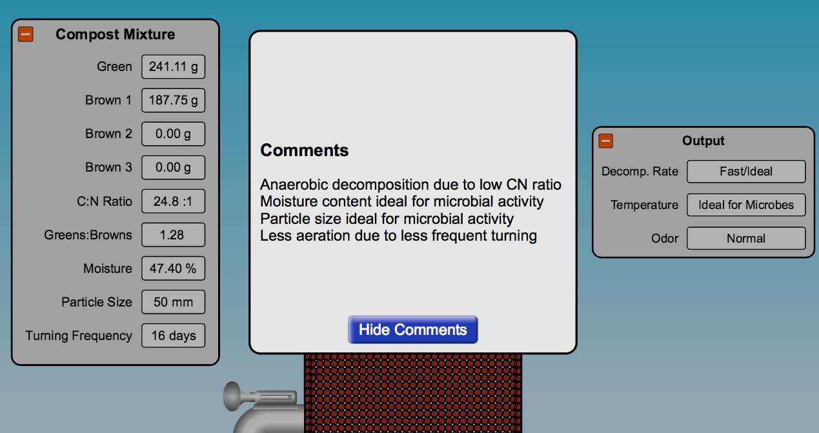
HOLOSTIC
The students found issues with the compost sim giving conflicting results between the output and the comments. When C:N ratio is low (along with turning frequency) the output is wrong.

When the turning frequency is 8 days or more, the output says fast/idea/....below that it says slow. Here are a few trials to show the issue.
Inputs: | Output:
Trial 1  TF: 16  PS: 50mm  C:N: 15:1 (all greens)  Moisture: 60% | DR: Fast/Ideal  Temp.: Ideal for Microbes  Odor: Normal  Comments: Anaerobic decomp due to low C:N ratio. Moisture ideal for microbe activity. Particle size ideal for microbial activity Less aeration due to less frequent turning
Trial 2  TF: 16  PS: 66 mm  C:N: 15:1 (all greens)  Moisture: 60% | DR: Fast/Ideal  Temp.: Ideal for Microbes  Odor: Normal  Comments: Anaerobic decomp due to low C:N ratio. Moisture ideal for microbe activity. Particle size ideal for microbial activity Less aeration due to less frequent turning
Trial 3  TF: 16  PS: 50mm  C:N: 22.3:1 (almost all greens)  Moisture: 50.55% | DR: Fast/Ideal  Temp.: Ideal for Microbes  Odor: Normal  Comments: Anaerobic decomp due to low C:N ratio. Moisture ideal for microbe activity. Particle size ideal for microbial activity Less aeration due to less frequent turning
Trial 3  TF: 8  PS: 50mm  C:N: 15:1 (all greens)  Moisture: 60% | DR: Fast/Ideal  Temp.: Ideal for Microbes  Odor: Normal  Comments: Anaerobic decomp due to low C:N ratio. Moisture ideal for microbe activity. Particle size ideal for microbial activity Less aeration due to less frequent turning

